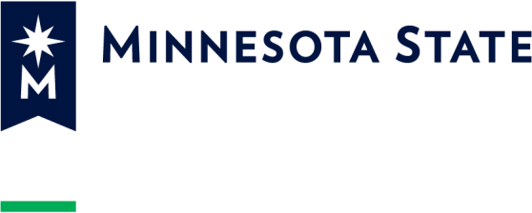

AtB Partnership Checklist

Check the line next to each statement if you agree.

We (i.e., campus and ABE representatives) have discussed why we want to implement the AtB State Process and/or the other two AtB options; each organization knows the others’ goals and intentions.
We agree to make student success and our ongoing relationship the focus of our partnership.
We have discussed career pathways and agree to one to four pathways in which to place students. We have documented this in the Career Pathways Checklist document.
We have discussed and agree to facilities sharing, data sharing and/or other ways to share our resources and information to facilitate our partnership. We have signed documentation reflecting our agreements.
We agree to meet regularly to discuss our process and improve it.
We agree to reach out to the system office and/or MDE/ABE leaders to resolve technical or relationship issues that impede implementing the State Process.
We agree that regular, positive communication is the foundation for a good partnership and includes at minimum:
- Holding regular meetings
- Using phone calls to resolve issues in the moment
- Copying other point people and key staff on emails to keep everyone in the communication loop
Please type in the names of the CPP and APP who agree with these statements, save this file, copy all signers in an email, attached the signed document and send to both james.verhoye@minnstate.edu and jess.niebuhr@minnstate.edu.

Campus Point Person (CPP) Date

ABE Point Person (APP) Date
Reference Information February 6, 2023
Strategic Partnerships AtB Partnership Checklist

Minnesota State is an Equal Opportunity Employer and Educator

