Connect and learn with World Education at the 2020 ProLiteracy conference!

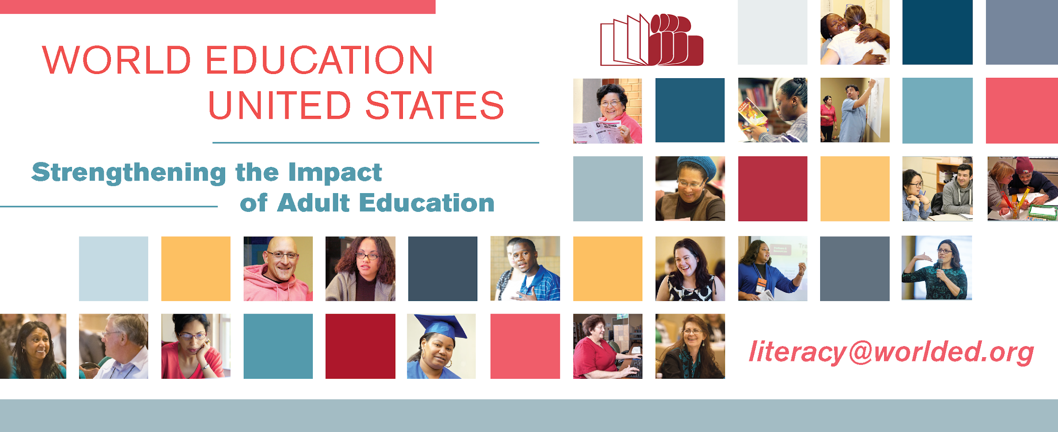

Check out these presentations by World Education staff:

Reducing Poverty by Partnerships between Adult Ed Programs, Libraries, and Immigrant Advocacy
Thursday, September 26th 9:00 a.m. – 10:00 a.m.
Marina 1

Digital Literacy in the Workplace: Employer-Provided Education Opportunities & Learner Motivations
Thursday, September 26th 10:15 a.m. – 11:15 a.m.
Marina 2

Digital Crossroads: At the Intersection of Adult Literacy and Digital Inclusion
Thursday, September 26th 1:00 p.m. – 2:00 p.m.
Marina 2

English Now!: Learning Circles for Engaging ESL Students
Thursday, September 26th 4:00 p.m. – 5:00 p.m.
Seabreeze 2

How Does the 2020 Census Impact Adult Education?
Friday, September 27th 8:00 a.m. – 9:15 a.m.
Ballroom C

Innovative Technology Tools and Use in Adult Learning & Employment: Findings from Field Testing
Friday, September 27th 10:45 a.m. – 11:45 a.m.
Marina 3

Join us at the Annual National College Transition Network conference on Advancing College and Career Readiness; Preparing Adult Learners for the Digital World November 11-13, 2019 in Cambridge, MA

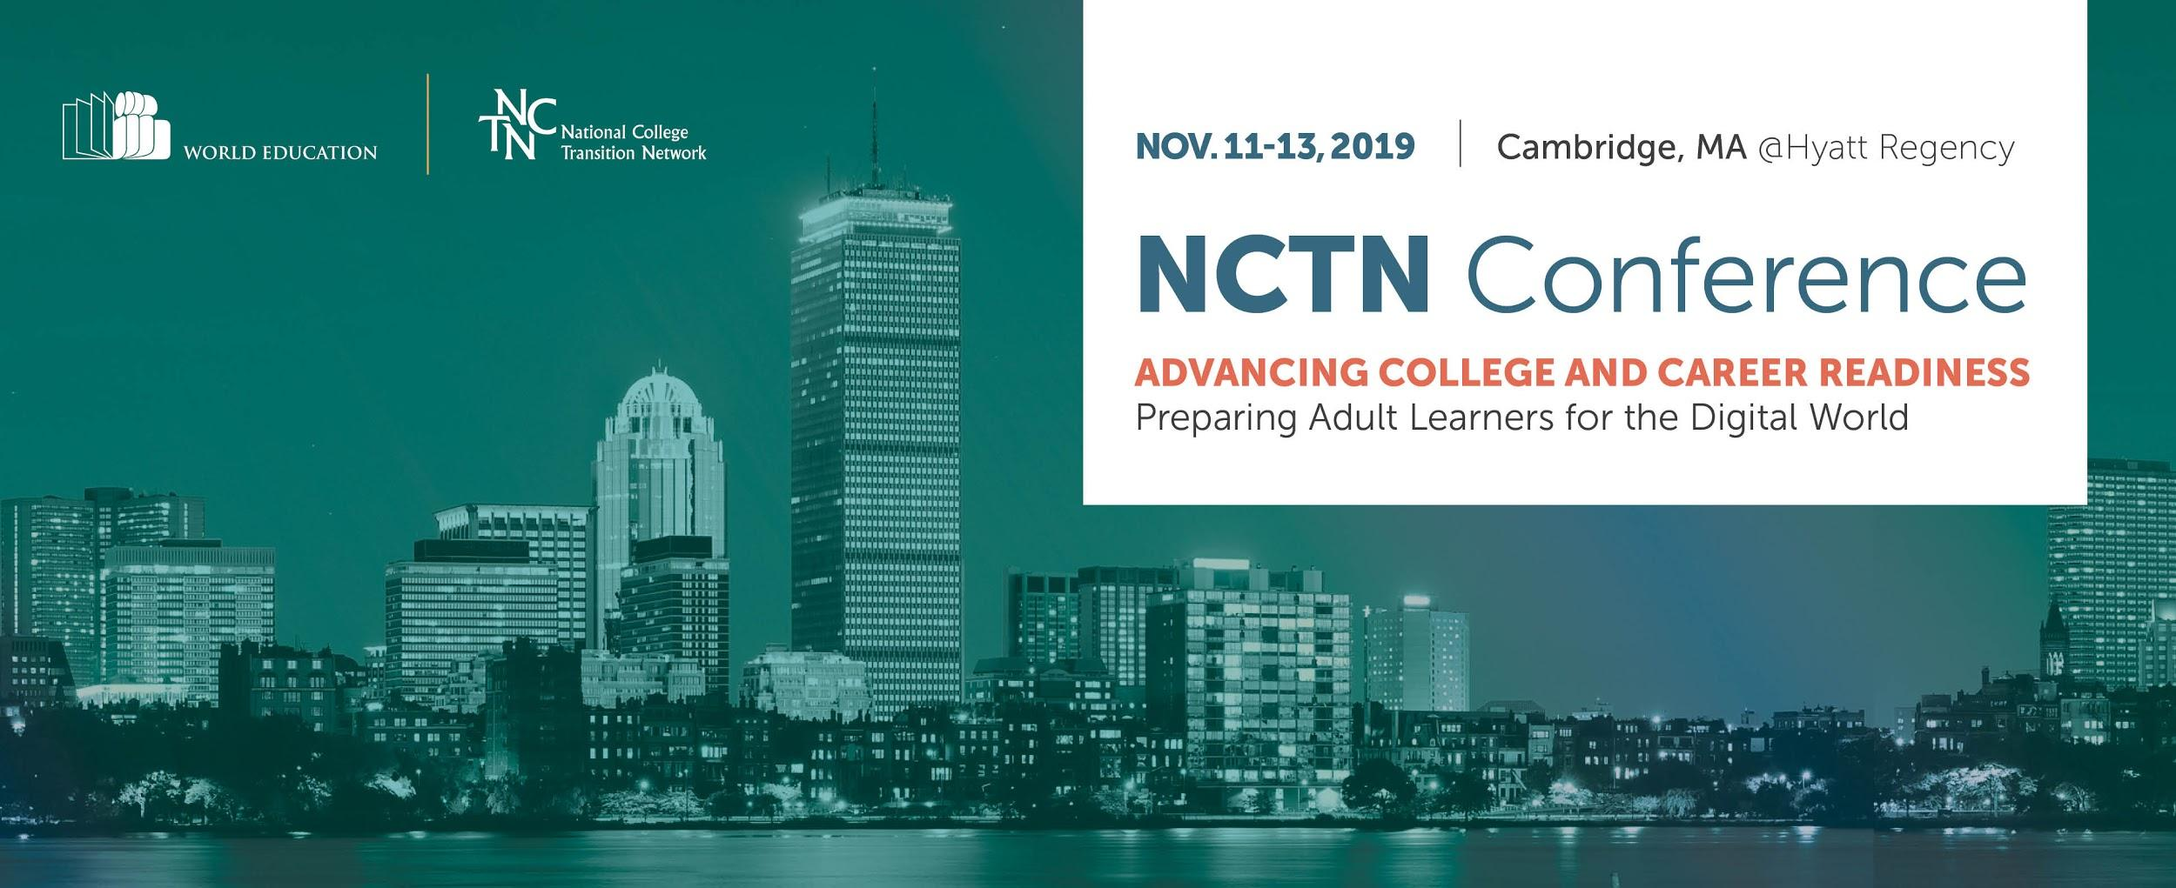

Register Now!

Get to know us better. Come by the World Education display table and pick up a free issue of The Change Agent magazine!

