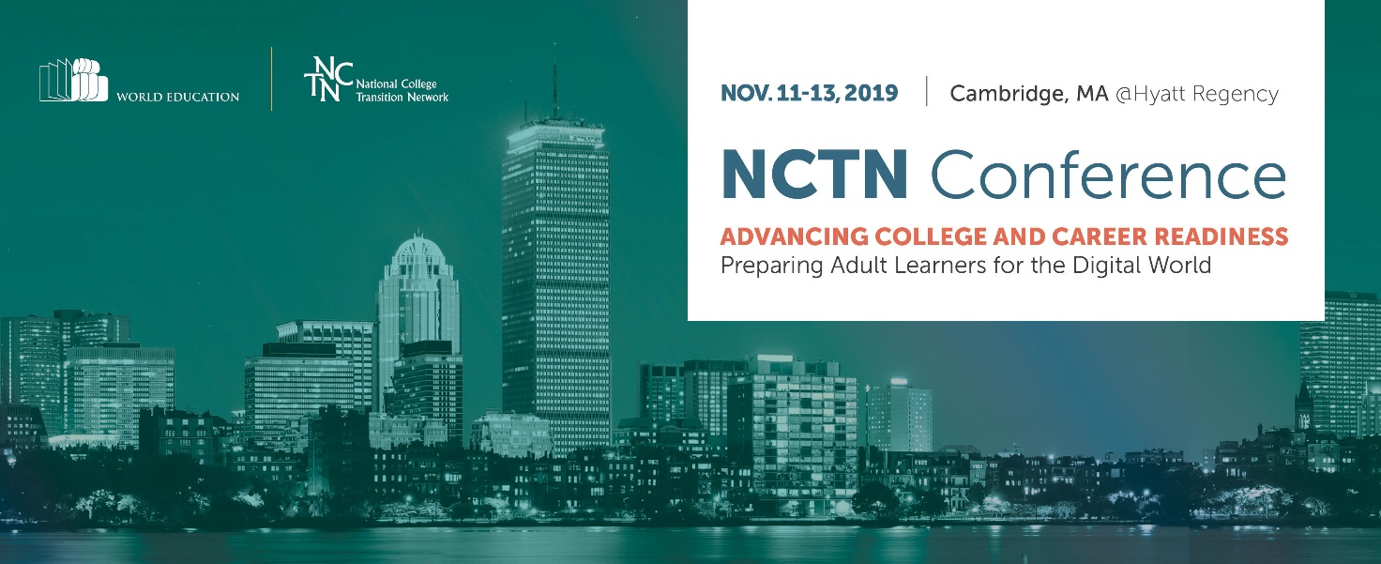
March 2019
Dear Colleague,
I hope all’s well with you. I’m reaching out to invite your organization to sponsor the National College Transition Network’s (NCTN) 13th annual conference November 11–13, 2019 in Cambridge. The conference builds the capacity of adult education providers and systems to ensure that adults are prepared and able to access educational and career opportunities of the future. The conference draws around 400 educators from community colleges and adult education programs from over 30 states.

The theme of this year’s conference is Preparing Adult Learners for the Digital World. The conference will showcase innovative, tech-enabled approaches to preparing adult learners for the digital world, leveraging the combined expertise of NCTN and our EdTech Center.

You know well that postsecondary credentials and industry-aligned competencies can mean the difference between low-waged underemployment and careers with good wages and opportunities for advancement. Enhanced 21st century skills and credentials that align with local labor market needs are the buffer against economic insecurity.

We would be thrilled to be able to count you among our sponsors. Please contact me or Priyanka Sharma, the Conference Coordinator to discuss how you would like to be involved: (617) 385-3788 or priyanka_sharma@worlded.org. See below for sponsorship details.

Best regards,
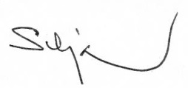
Silja Kallenbach, Vice President
Conference Sponsorship & Advertising Opportunities
Sponsorship and advertising opportunities are available for the 2019 NCTN National Conference. Support the Conference and the work of the NCTN by becoming a sponsor. Please complete the following form by June 30, 2019.
◻ Platinum Sponsor: $10,000 +
- Link/Logo posted as Platinum Sponsor on the NCTN website (Over 60,000 unique visitors to the site per year) and recognition in NCTN’s e-newsletter sent to over 3,500 members
- Full page color ad recognizing your support in the conference program
- Promotional material distribution option will be available
- Advertisement placement with your link on conference website next to event sponsored
- Premium booth location at the conference
◻ Gold Sponsor: $5,000
- Link/Logo posted as Gold Sponsor on the NCTN website for one year and recognition in NCTN’s e-newsletter sent to over 3,500 members
- Full page color ad recognizing your support in the conference program
- Option to present a vendor webinar for NCTN members and partners
- Promotional material distribution option will be available
- Premium booth location at the conference
◻ Silver Sponsor: $2,500
- Link/Logo posted as Silver Sponsor on the NCTN website and recognition in NCTN’s e-newsletter sent to over 3,500 members
- Half page color ad recognizing your support in the conference program
- Option to present a vendor workshop
- Complimentary booth at the conference
Sponsorships are payable by check (payable to NCTN/World Education) or by credit card through PayPal. Please return the completed form to us.
By email: nctn@worlded.org
By mail: NCTN/World Education, Attn. Priyanka Sharma, 44 Farnsworth St, Boston MA 02210.
World Education is a tax exempt non-profit EIN # 13-1804349.
Sponsorship & Payment Information

Company Name

Contact Name

Title

Address

Telephone (____)__________________________________ Fax (____)

Email

Sponsorship Level/Amount $ ________
Payment method:
___ Check payable to NCTN/World Education
___ Credit Card (through PayPal – contact Ebony Vandross, evandross@worlded.org, for details)
___ Purchase Order P.O. Number ____________

Questions?
Email: nctn@worlded.org
Phone: Priyanka Sharma at 617-385-3788
Testimonials
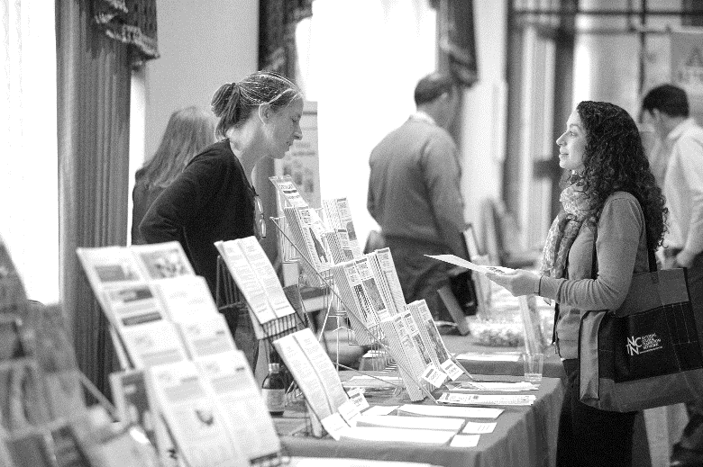
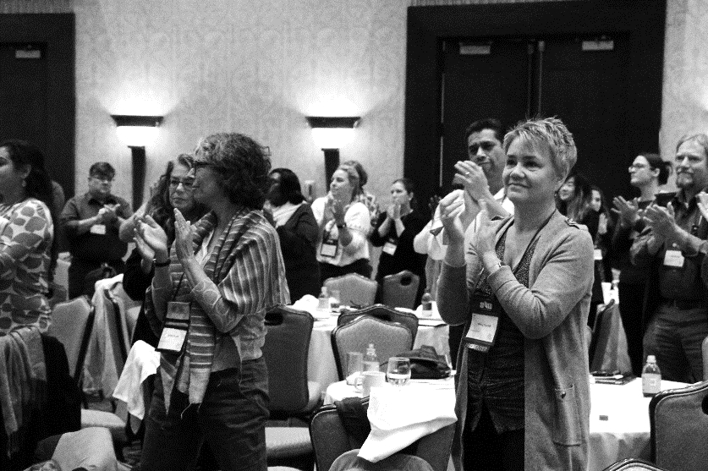
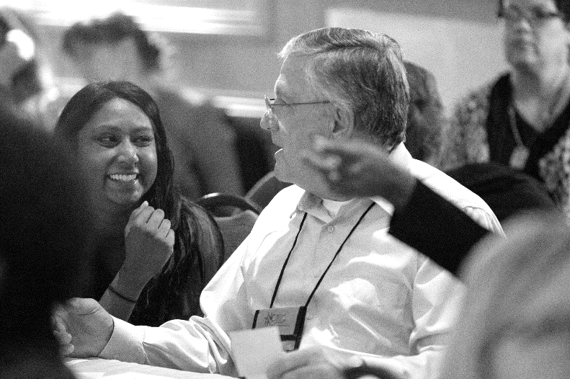

"Great relevant session topics."

"I think the conference this year had the perfect combination of everything I needed to hear. It’s the best conference I’ve attended in ages!"
"Excellent keynotes and exceptional, well-moderated panels; pragmatic focus to workshops - great to have a focus on policy and future of work."

"There were some really good sessions that sparked extensive conversation that was extremely helpful."
"[I liked] meeting attendees from other states and gaining a broader picture. Hearing about initiatives, I wouldn't normally be exposed to ... Seeing colleagues from other states whom I already know. Feeling like there are other people out there who care about the same things I do!"

