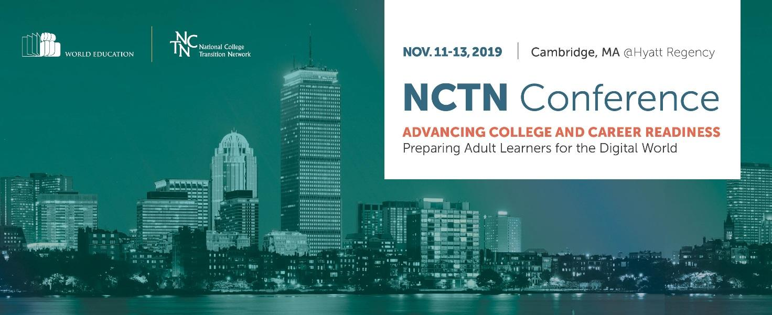
July 2019
Kevin Morgan, CEO
ProLiteracy
Dear Kevin,
I’m delighted that ProLiteracy will partner with us again as a sponsor of the National College Transition Network’s (NCTN) annual conference that builds the capacity of adult education providers and systems to ensure that adults are prepared and able to access educational and career opportunities of the future. At ProLiteracy, you know well that postsecondary credentials and industry-aligned competencies can mean the difference between low-wage underemployment and careers with good wages and opportunities for advancement.
The theme of this year’s conference is Preparing Adult Learners for the Digital World. The conference will showcase innovative, tech-enabled approaches to preparing adult learners for the digital world, leveraging the combined expertise of NCTN and our EdTech Center. The 2019 conference will be held November 11–13 in Cambridge, MA. The conference draws around 400 educators from community colleges and adult education programs from over 30 states.
Please contact Sydney Breteler, the Conference Coordinator to discuss how you would like to be involved: (617) 385-3797 or sydney_breteler@worlded.org. See below for sponsorship details.

Thank you for your long-standing partnership with us on so many fronts. I look forward to seeing you and attending your conference in September.

Best regards,
Silja Kallenbach, Vice President
Conference Sponsorship & Advertising Opportunities
Sponsorship and advertising opportunities are available for the 2019 NCTN National Conference. Support the Conference and the work of the NCTN by becoming a sponsor. Please complete the following form by July 31, 2019.
◻ Platinum Sponsor: $10,000 +
- Link/Logo posted as Platinum Sponsor on the NCTN website (Over 60,000 unique visitors to the site per year) and recognition in NCTN’s e-newsletter sent to over 3,500 members
- Full page color ad recognizing your support in the conference program
- Promotional material distribution option will be available
- Advertisement placement with your link on conference website next to event sponsored
- Premium booth location at the conference
◻ Gold Sponsor: $5,000
- Link/Logo posted as Gold Sponsor on the NCTN website for one year and recognition in NCTN’s e-newsletter sent to over 3,500 members
- Full page color ad recognizing your support in the conference program
- Option to present a vendor webinar for NCTN members and partners
- Promotional material distribution option will be available
- Premium booth location at the conference
◻ Silver Sponsor: $2,500
- Link/Logo posted as Silver Sponsor on the NCTN website and recognition in NCTN’s e-newsletter sent to over 3,500 members
- Half page color ad recognizing your support in the conference program
- Option to present a vendor workshop
- Complimentary booth at the conference
Sponsorships are payable by check (payable to NCTN/World Education) or by credit card through PayPal. Please return the completed form to us.
By email: nctn@worlded.org
By mail: NCTN/World Education, Attn. Sydney Breteler, 44 Farnsworth St, Boston MA 02210.
World Education is a tax-exempt non-profit EIN # 13-1804349.
Sponsorship & Payment Information

Company Name

Contact Name

Title

Address

Telephone (____)__________________________________ Fax (____)

Email

Sponsorship Level/Amount $ ________
Payment method:
___ Check payable to NCTN/World Education
___ Credit Card (through PayPal – contact Ebony Vandross, evandross@worlded.org, for details)
___ Purchase Order P.O. Number ____________

Questions?
Email: nctn@worlded.org
Phone: Sydney Breteler at 617-385-3797

