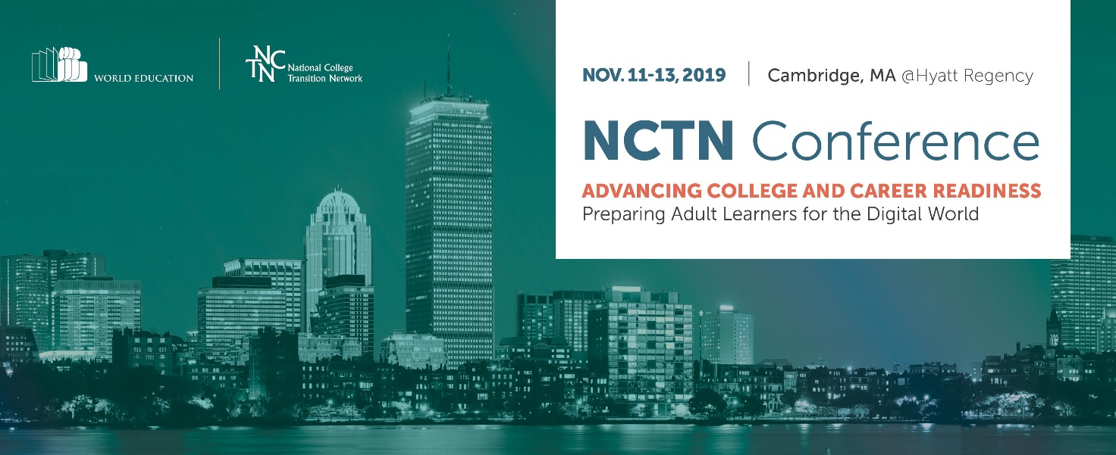
Dear Colleague,
I’m reaching out to you to see if your organization would consider being a sponsor of our National College Transition Network’s (NCTN) 13th annual conference November 11–13, 2019. This year we’re holding it in Cambridge, MA at the Hyatt Regency. You know well that postsecondary credentials matter for low-income adults and their families more than ever as a buffer against economic insecurity and that not just any credentials, but ones that correspond to local labor market needs.

The conference is an important part of the NCTN’s strategy in building the capacity of adult education providers and systems to prepare low-income, lower-skilled adults so that they can successfully compete for good jobs in this rapidly changing economy. It provides a forum for adult education, workforce development, and postsecondary educators, advisors, and administrators to learn from experts and each other.

Without adult education programs’ intervention, the odds are truly against adults’ ability to persist and complete postsecondary education and training. We would be thrilled to be able to count your organization among our sponsors.

Please contact me to discuss how you would like to be involved: (617) 385-3788 or priyanka_sharma@worlded.org. See below for sponsorship details.

Best regards,
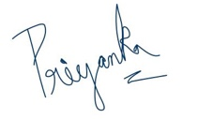
Priyanka Sharma

Conference Sponsorship & Advertising Opportunities
Sponsorship and advertising opportunities are available for the 2019 NCTN National Conference. Support the Conference and the work of the NCTN by becoming a sponsor. Please complete the following form by August 15, 2019.
◻ Platinum Sponsor: $10,000 +
- Link/Logo posted as Platinum Sponsor on the NCTN website (Over 60,000 unique visitors to the site per year) and recognition in NCTN’s e-newsletter sent to over 3,500 members
- Full page color ad recognizing your support in the conference program
- Promotional material distribution option will be available
- Advertisement placement with your link on conference website next to event sponsored
- Premium booth location at the conference
◻ Gold Sponsor: $5,000
- Link/Logo posted as Gold Sponsor on the NCTN website for one year and recognition in NCTN’s e-newsletter sent to over 3,500 members
- Full page color ad recognizing your support in the conference program
- Option to present a vendor webinar for NCTN members and partners
- Promotional material distribution option will be available
- Premium booth location at the conference
◻ Silver Sponsor: $2,500
- Link/Logo posted as Silver Sponsor on the NCTN website and recognition in NCTN’s e-newsletter sent to over 3,500 members
- Half page color ad recognizing your support in the conference program
- Option to present a vendor workshop
- Complimentary booth at the conference
Sponsorships are payable by check (payable to NCTN/World Education) or by credit card through PayPal. Please return the completed form to us.
By email: nctn@worlded.org
By mail: NCTN/World Education, Attn. Priyanka Sharma, 44 Farnsworth St, Boston MA 02210.
World Education is a tax exempt non-profit organization (EIN# 13-1804349).
Sponsorship & Payment Information

Company Name

Contact Name

Title

Address

Telephone (____)__________________________________ Fax (____)

Email

Sponsorship Level/Amount $ ________
Payment method:
___ Check payable to NCTN/World Education
___ Credit Card (through PayPal – contact Ebony Vandross, evandross@worlded.org, for details)
___ Purchase Order P.O. Number ____________

Questions?
Email: nctn@worlded.org
Phone: Priyanka Sharma at 617-385-3788
Testimonials
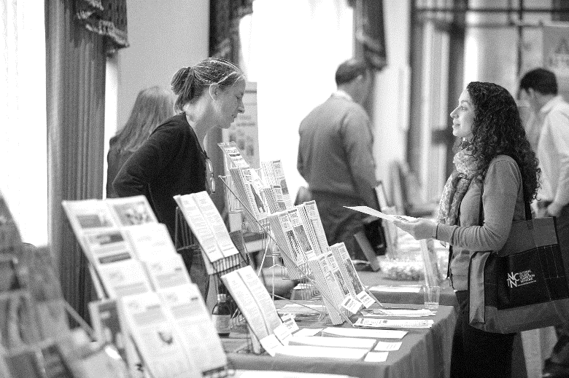
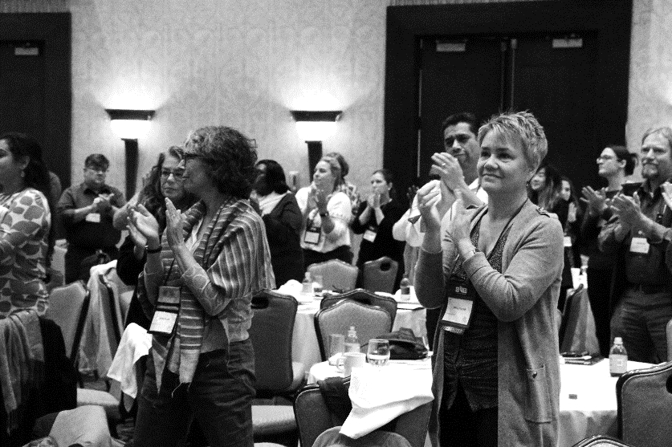
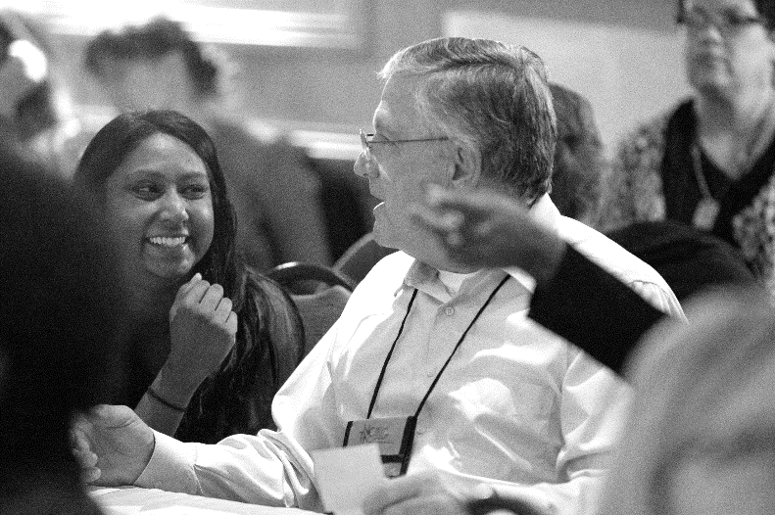

"Great relevant session topics."

"I think the conference this year had the perfect combination of everything I needed to hear. It’s the best conference I’ve attended in ages!"
"Excellent keynotes and exceptional, well-moderated panels; pragmatic focus to workshops - great to have a focus on policy and future of work."

"There were some really good sessions that sparked extensive conversation that was extremely helpful."
"[I liked] meeting attendees from other states and gaining a broader picture. Hearing about initiatives, I wouldn't normally be exposed to ... Seeing colleagues from other states whom I already know. Feeling like there are other people out there who care about the same things I do!"

