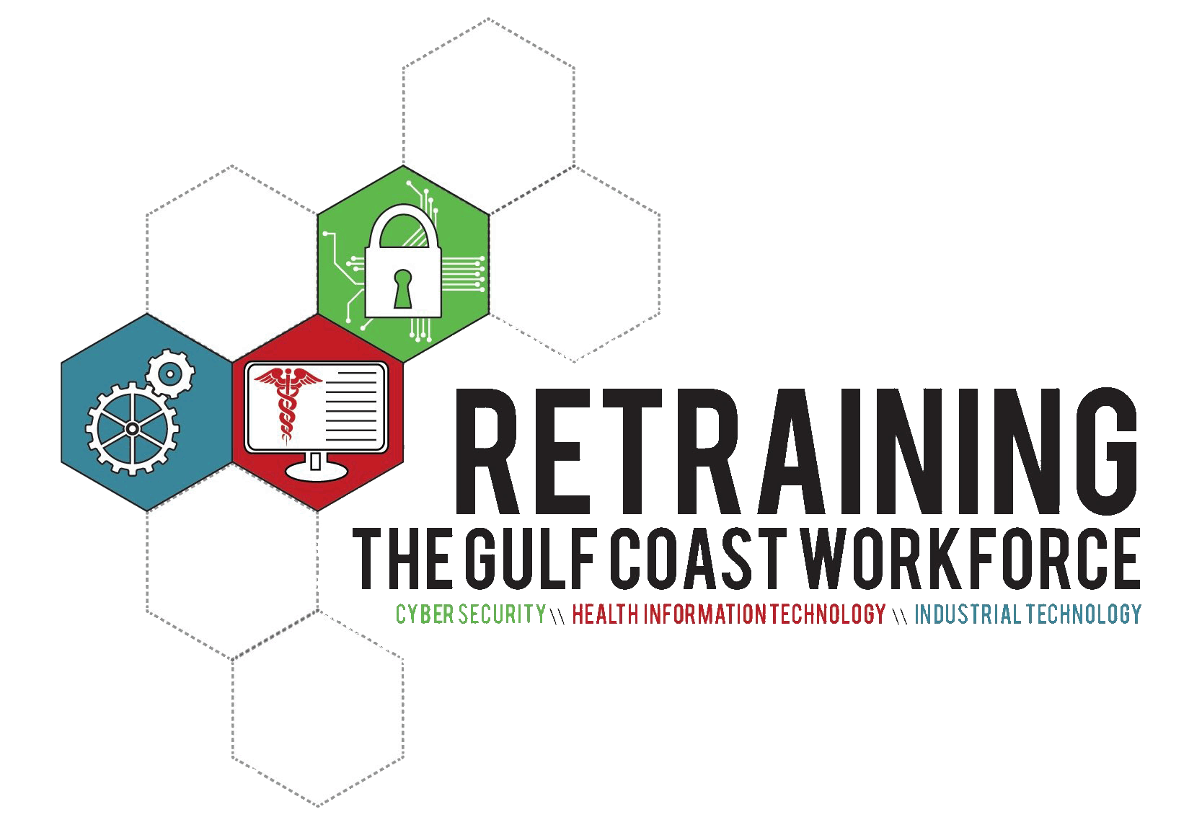
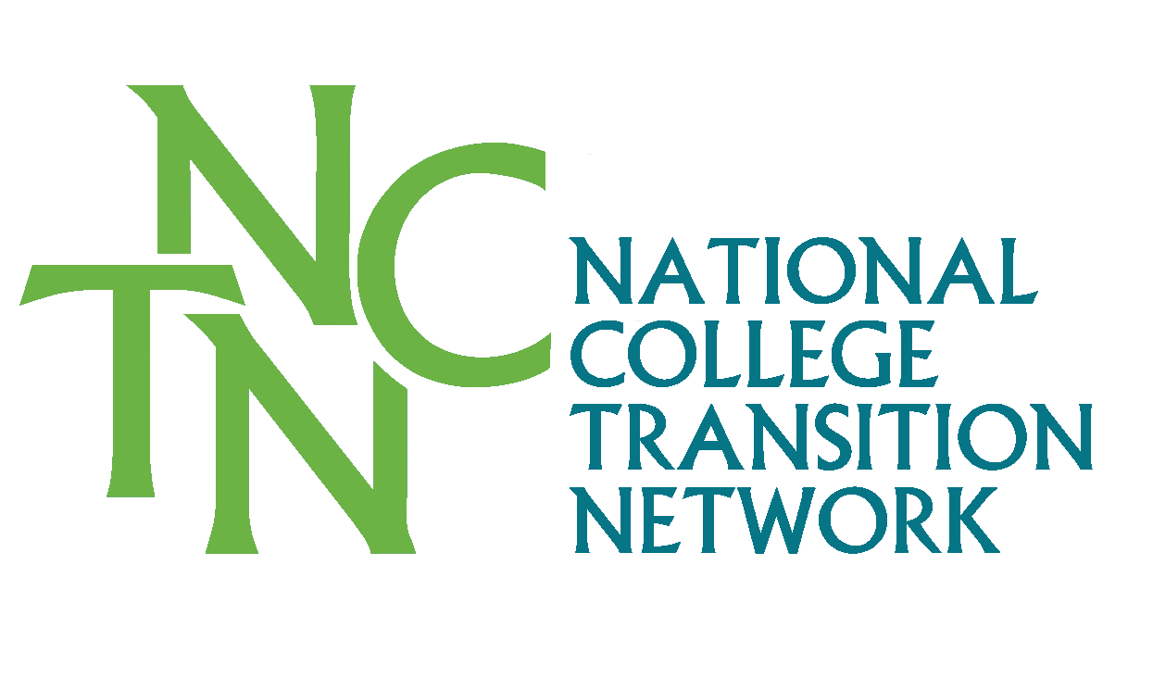
STAFF Guide to Prior Learning Assessment
Helping Students Through the PLA PROCESS
pla Overview
Prior Learning Assessment (PLA) is an evidence-based acceleration and completion strategy to recognize and award credit for college-level learning. The process enables learners to demonstrate what they have learned and translate that learning into college credit. PLA validates knowledge acquired through life experience, work experience, military experience, civic engagement, individual study and reading, and participation in classes or training sponsored by business and industry, professional organizations, or government agencies.
Credit is awarded for college-level knowledge gained from experience and/or training. Credit is not awarded for the experience itself. College-level learning is validated through PLA when learners prove their mastery of the knowledge, skills, competencies, and abilities in a specific area of study offered by the college.
A Council for Adult and Experiential Learning (CAEL) study, Fueling the Race to Postsecondary Success: A 48-Institution Study of Prior Learning Assessment and Adult Student Outcomes, found that adults who earned credit through PLA had higher completion rates and took less time to complete a degree than students who had not earned PLA credit. In fact, these learners were two-and-a-half times more likely to complete a degree! This was true for students regardless of race/ethnicity, age, financial aid status, or gender. Additionally, credits earned through PLA save students time and money in completing a degree or certificate.
about the guide
Navigators and Program Advisors play an integral role in student success by guiding prospective and current students through their educational pathway. The staff needs to be familiar with the college’s PLA policies so that they can inform the students about the potential Prior Learning credit opportunities that are available to them.
This guide is geared towards you, the staff, and builds on previous PLA resources that are available to help you further understand your college’s PLA policies and procedures. Some of these documents are part of the Addendum that follows the guide and others are referenced in the Resources section.
As a companion to using this guide, you’ll need to locate your college’s PLA Policies and Procedures so that you have a deeper understanding of the role of the Registrar, Bursar’s Office, Faculty, Department Chairs, or Chief Academic Officer etc. in the overall PLA process. The Faculty Guide to PLA (July 2015) is an excellent resource to further understand the faculty’s role in PLA process.
This guide contains following five tools with suggested uses and instructions:

- Prior Learning Student Survey
- Jeopardy Game Example
- Prior Learning Options Matrix
- Guide to the Virtual Career Network
- Request Procedure for Prior Learning

I. Prior Learning Student Survey
Prior Learning Assessment is the process of awarding academic credit to learning that has taken place outside of the classroom, either from non-credit courses, industry training, military training, work experience, reading, or private study.

This Prior Learning Survey tool is designed to help identify college-level knowledge and skills that your students may have already acquired. The information can help them reflect on and record all areas of potential prior learning outside the classroom so that you can identify the potential for earning college credit. Ask them to be as detailed as possible when completing this survey.

When using this survey tool with your students, be sure that they understand that the purpose is to help them identify prior learning, pre-screen them for information that will trigger a referral for more information about options for applying for credit. Completion of this survey does not guarantee that credit will or can be awarded. This information allows you to better identify if they may be potential candidates of the prior learning process.

Note: This survey tool has been adapted from a version developed by the GCIT team at Delgado Community College with assistance from NCTN.

Prior Learning Student Survey
I. Contact Information
1. Last Name: _____________________________________
2. First Name: _____________________________________
3. Primary E-mail Address: ___________________________
4. Primary Phone #: ________________________________
II. What is your Pathway? [Check one]
__ Healthcare
__ Information Tech – Advanced Manufacturing
__ Information Tech – Network Security
__ Technical Trades – Electrical
__ Technical Trades – HVAC
__ Technical Trades – Welding
__ Other: _________________________
III. Please fill-in details in the sections that apply to you if you believe that you have knowledge, skills, or learning from any of the areas below that can be applied to your chosen Pathway.
A. Non-Credit Coursework [Advanced Placement courses, vocational or technical programs, non-accredited professional school classes, etc.]

Name of the Institution(s) where learning was acquired:
_____________________________________________
_____________________________________________

Course Names:
_____________________________________________
_____________________________________________
_____________________________________________
_____________________________________________

B. Licenses or Industry Certifications

List any industry-related licenses that you have: [e.g. Contractor’s license, plumber’s license etc.]

_____________________________________________
_____________________________________________

Do you have any industry-recognized certification in your Pathway: [Check all that apply]
__ NCCR
__ NIMS
__ AWS
__ OSHA
__ CompTIA
__ MTA
__ IC3
__ CAN
__ Other: ______________________________

C. Training [Corresponding courses, seminars, conferences, workshops, continuing education, formal military training, clinics, television/radio courses, etc.]

Name of the training acquired:
_____________________________________________
_____________________________________________

Name of the training provider:
_____________________________________________
_____________________________________________

Date completed:
_____________________________________________

Skills gained or knowledge learned:
_____________________________________________
_____________________________________________
_____________________________________________
_____________________________________________

D. Relevant Work Experience

Name of the employer where learning was obtained:
_____________________________________________
_____________________________________________

Position Title:
_____________________________________________

Length of employment:
_____________________________________________

Skills learned:
_____________________________________________
_____________________________________________
_____________________________________________
_____________________________________________

E. Volunteer Experience

Name of the organization where learning was obtained:
_____________________________________________
_____________________________________________

Volunteer Role Title:
_____________________________________________

Length of volunteer stint:
_____________________________________________

Skills learned:
_____________________________________________
_____________________________________________
_____________________________________________
_____________________________________________

F. Independent Learning or Recreational Activities [Independent research, self-taught computer or technical skills, extensive reading, published or posted writing, public speaking, foreign languages, or acting, theater production, musical performance, website creation, graphic design, drawing and painting, sculpting etc.]

Name of the learning activity or fine art medium:
_____________________________________________
_____________________________________________
_____________________________________________
_____________________________________________

Length of time engaged in activity or fine art medium:
_____________________________________________

Skills learned and/or accomplishments:
_____________________________________________
_____________________________________________
_____________________________________________
_____________________________________________

II. JEOPARDY GAME EXAMPLE
You can introduce some prior learning terms and concepts in an entertaining way by conducting a Jeopardy-type game during a group event like a student orientation, recruitment fair, or even at a staff meeting!
This following template contains a sample set of Prior Learning Assessment Jeopardy game definitions. An online version of this game is also available and can be accessed by clicking through the links below.
To conduct the game, divide the group into 2-3 teams, ask a team to volunteer to choose a category and point value to begin. Explain to the group that they must give the answer in the form of a question and the higher the point number, the harder the answer is. You as the game facilitator now read aloud the definition of the chosen category and point value. Teams raise their hands to give the correct term. The team that gets the answer right gets the point value of the question added to their score. Do this until all the definitions have been chosen. Teams add up the number of points received. The team with the most points wins!
To play: jeopardylabs.com/play/jeopardy-the-pla-edition
To edit: jeopardylabs.com/edit/jeopardy-the-pla-edition
Password: gcitpla

Note: If you are planning to edit the game for your use, please make a copy of the existing game before you start to make any changes.

Jeopardy – The Prior Learning Assessment Edition
The Basics | Name that Assessment | Starts with “P”
Acronym for Prior Learning Assessment  [What is PLA?] | Provides flexibility for the way credit is earned or awarded, with emphasis on personalized learning opportunities.  [What is Competency-based Learning?] | According to a CAEL study, graduation rates are 2.5 times higher for students with this.  [What is a PLA credit?]
This type of learning can occur in a variety of personal and professional settings.  [What is college level learning?] | Compilation of data in an approved format to demonstrate college-level knowledge.  [What is a portfolio?] | This course can guide students through a process to document their prior learning.  [What is a [PLA] Portfolio Development course?]
- Shortens time to degree or certificate  - Acknowledges the college level learning that adult students have gained  - Builds confidence  - Avoids duplication of classes and learning  [What are the benefits of PLA?] | An exam developed by faculty that mimics a final examination in a credited course.  [What is a challenge exam?] | GCIT Consortium colleges have made good progress on these as far as PLA is concerned.  [What are (PLA) Policies and Procedures?]

III. Prior Learning Options Matrix
The Prior Learning Options Matrix is a tool to help you understand and recommend the corresponding prior learning options that are potentially available for your students based on their previous knowledge, skills, and experiences.
Prior Learning Options Matrix Example
    If this applies to your students  Suggest this | Credit by exam (e.g. CLEP, or faculty-developed challenge exam etc.) | Credit through evaluated program [e.g. American Council on Education (ACE) or NCCRS] | Credit through evaluated credentials | Portfolio development | Notes
Expert knowledge in career field |  |  |  |  | See Challenge Exams and Credentials Crosswalks, if available.
Corporate and Employer training |  |  |  |  | See Challenge Exams and Credentials Crosswalks, if available.
Military training/courses |  |  |  |  | Refer to Office of Veteran Services. Also refer to Guide to Awarding Military Credit [see Resources].
Professional Certificates |  |  |  |  | Refer to Office of Veteran Services. Also refer to Guide to Awarding Military Credit [see Resources].
Experiential learning through events such as community involvement, family life, or civic activities, etc. |  |  |  |  | See Challenge Exam and Credentials Crosswalks, if available.

Adapted from Northern Virginia Community College’s Prior Learning Assessment Guide: Using Credits from Non-traditional Sources, August 2013.
IV. Guide for Virtual Career Network
Another tool you have available for advising students on possible credit for prior learning, is the Virtual Career Network (VCN) website [www.vcn.org/index.php]. It is a tool developed by the U.S. Dept. of Labor and American Association of Community Colleges.


VCN platforms have been developed for health care, green jobs, and transit-related occupations for students to research occupations and training in those industries. However, the section devoted to earning college credit for prior learning is not industry specific and is the same across each of the VCN areas.
Virtual Career Network Features:
Career Management Account (“My VCN”)
Users can create a virtual portfolio to store results from career assessments and career exploration (career wish lists). They can save information about careers, educational programs, and job openings that they wish to explore further. The Learning Inventory that is used to document prior learning, such courses, national certifications, and other credentials that might be worthy of college credit, is saved in the Career Management Account.

Learning Exchange
Users can take noncredit remedial and technical skill development courses online that prepare them for a pathway into health care careers. These include basic skills refresher courses as well as specialized health career courses.

Earn Credit for Prior Learning
Users are guided through a process for reviewing and documenting previous college courses, military training, professional training, and national certification exams, to store in a Learning Inventory. The Learning Inventory uses the information entered by the student to generate a cover letter, which a student can submit to their advisor to initiate a prior learning assessment request/application process.

The VCN data base contains professional training courses that have been evaluated by the American Council on Education (ACE) for credit recommendations. If a student has taken a training course or received a certification that isn’t found in the data base, it doesn’t mean that there is no potential to earn credit. It just means that the college would need to make a local decision about whether and how to asses for credit, perhaps through a crosswalk process.

Though all PLA policies and procedures are set by individual colleges, advisors and navigators can use this platform with students to compile a prior learning inventory. It’s important to remind students that the VCN doesn’t guarantee credit. It simply helps students to consider whether they might be eligible for credit and helps them prepare a request to the specific college they attend.

V. Request Procedure for Prior Learning – Credit by Examination Example
A student who believes that he/she is qualified for college credit from learning earned through experience, previous training, military experience/training or noncredit coursework may request credit by examination. This request needs to be in alignment with the existing Prior Learning Assessment (PLA) policy of your institution. You will be able to find additional details about the Credit by Examination process in the Faculty Guide to Prior Learning Assessment (July 2015). The following flow chart demonstrates a sample process for attempting to receive credit by examination from a student’s perspective.
Consult with PLA designated contact or Registrar’s Office
- Speak with the appropriate faculty member
- Discuss process and forms
- Identify course/s for challenge exams

Complete PLA review application
- Review the application
- Determine eligibility
- Confirm assessment methods & procedures

Schedule meeting with Department Chair/Faculty/ Dean
Pay assessment fees to the Bursar’s Office

Prepare for prior learning assessment
- Review your skills and knowledge
- Collect, create & compile evidence
- Obtain validations
- Meet timelines

Challenge assessment facilitated and then evaluated by faculty assessor
Results submitted to Registrar
Candidate notified of results
Successful: See academic transcript!
Not successful: letter sent
- Consult with faculty
- Register for course
- Grade appeal process available

RESOURCES
Additional documents, handbooks and tools developed by NCTN for the Retraining the Gulf Coast Workforce through IT Consortium provide useful information for your practice. A selection of these resources are listed below and can be found at gulfcoastittraining.com/documentation/prior-learning-assessment-documentation and also on the NCTN website at www.collegetransition.org/PLAdocuments.html.
Faculty Guide to Prior Learning Assessment and Challenge Exams summarizes ways to award PLA credit with a strong emphasis on the development and use of challenge exams, and awarding of credit for professional certifications/industry credentials and state licensure.
Retraining The Gulf Coast Workforce Through IT Pathways Consortium: Prior Learning Assessment (PLA) Best Practices provides examples of “best practices” among GCIT peers regarding PLA policies and practices. By working collaboratively as a Consortium and peer learning group, the sharing of these practices assisted in the development of the training, practices and policies needed to achieve consistency and a streamlined approach to PLA practices among all nine colleges.
Effective PLA Policies and Practices Components and Benchmarks provides the information needed to ensure that each college has policies and procedures in place to validate college-level knowledge acquired through experiential learning that are aligned with state policy and the accreditation standards of the Southern Association of Colleges and Schools (SACS).
Military Credit Transcript Crosswalk Template guides the awarding of credits to veterans based on courses evaluated and approved for course substitution by the Joint Services Transcripts Crosswalk and the Community College of the Air Force Credit Crosswalk.
Credit for Prior Learning Procedure Template provides the understanding and articulation of clear PLA procedures and allows for customization at each college.
Credit for Prior Learning Policy Template augments the Credit for Prior Learning Procedure Template. It guides the development and revision of institutional policies, and is supported by Mississippi Board for Community Colleges (MCCB) and Louisiana Community and Technical College System (LCTCS).
Credit for Prior Learning Examination Crosswalk offers clarity for college’s awarding credit for prior learning based on standardized examinations (e.g., CLEP, DSST, AP) and professional certifications.
ADDITIONAL RESOURCES
American Council on Education (ACE) Credit Recommendation Service
www.acenet.edu/AM/Template.cfm?Section=CCRS
ACE Military Guide Online
militaryguides.acenet.edu
Council for Adult and Experiential Learning (CAEL) www.cael.org

ADDENDUM

~ Request Procedure for Prior Learning – NEMCC Example ~

~ Student PLA Video Companion Guide ~


Request Procedure for Challenge Exam Flowchart
STEP 1: Consult with the appropriate instructor.
- Speak with the instructor of the class you wish to challenge.
- Discuss process and forms
- Identify course/s for challenge exams

STEP 2: Complete The NEMCC Application for Admissions online at www.nemcc.edu/apply-online/ , print it, sign it, & date it.

3
http://www.nemcc.edu/apply-online/http://www.nemcc.edu/apply-online/
STEP 3: Submit the NEMCC Application for Admissions to your instructor.
- Secure the appropriate email address from your instructor for the NEMCC professor that you will email to request a seat for the specific challenge exam you wish to attempt.
- Be sure to email form

STEP 4: Email the NEMCC professor to request a seat for the specific challenge exam.

STEP 5: Wait for email from NEMCC staff containing a probable exam date and time.
- Review your schedule for the date and time for the challenge exam
- Respond to the Email and accept the invitation to attempt the exam

STEP 6: Challenge assessment facilitated and then evaluated by faculty assessor
STEP 7: Results submitted to Registrar
STEP 8: Candidate notified of results
Successful: A score of 70 or above will reward “Z” grades for college credits.
- Student will pay a $50.00 transcript fee for the “Z” grade to be placed on the student’s NEMCC record
Not successful: 69 or below will constitute a “no pass”
- Student may re-take the exam only once more not to exceed two attempts per challenge exam.

Submitted by Shawn Davis, Navigator at Northeast Mississippi Community College (July 2015).
[Community College Name]
COMPANION GUIDE FOR STUDENT PLA VIDEO
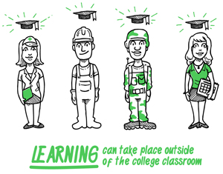
Prior Learning Assessment (PLA) offers a proven pathway to increase student persistence and accelerate degree completion in higher education. A recent study conducted by the Council for Adult and Experiential Learning (CAEL), Fueling the Race to Postsecondary Success, affirms what to some may seem like conventional wisdom - when college students earn credit for content they already know, they show more positive academic results.
The Student PLA Video frames the value of lifelong learning experiences and the potential and value of receiving college credit for these informal learning opportunities. The PLA Video is geared towards students who are planning to apply for or have been accepted in a program of study in your community college. It can be shown at a student recruitment event, program orientation, or in a one-on-one advising setting.
The intention of this video is to raise students’ awareness about the potential of PLA and introduce them to the PLA processes in your community college. As Navigators, Advisors, and Program Coordinators, it is important for you to be familiar with the PLA policies and procedures in your college so that you can guide the students in their PLA next steps.
Video and Supporting Materials:
- Permanent Video Link: www.collegetransition.org/PLAvideo.html.
- PLA Process and Policy documents specific to [college name].
- Military Credit Transcript Crosswalk specific to [college name].
- Credit for Prior Learning Examination Crosswalk specific to [college name].
- Additional PLA documents are available at www.collegetransition.org/PLAdocuments.html.
The following are potential scenarios with assumptions, preparation suggestions, and discussion questions you can use when showing the video to specific target audiences.

Scenario #1 - Student Recruitment Event
Assumption: These are students are considering enrollment and are not aware of PLA policies or opportunities.
Audience: Prospective students
Preparation:
- Be familiar with [college name]’s current PLA policy or check with someone from the Registrar and/or Dean’s office regarding the PLA policy details;
- Try to find examples of students that have pursued and completed the PLA process;
- Review Staff Guide to PLA (August 2015);
- Explore your college website to see what PLA information is shared.
Discussion Guide:
- Ask the students if they had ever heard about PLA before this video. What are their thoughts about it?
- Ask the students what questions arose as they watched the video?
- Ask the students to take a moment to reflect on their own prior training, professional, and work experiences and make a note of some that they think that the learning gained could translate into college credits (this could be a Pair-Share activity).
- Discuss a sample PLA process in your college and share a student’s PLA journey story if you were able to locate one.
- Reiterate the Call to Action in the video by explaining the next steps that students might need to take to pursue a PLA process and share the contact information for the PLA point person.
What are some of your ideas for sharing this video with your students to increase their knowledge of and familiarity with PLA?

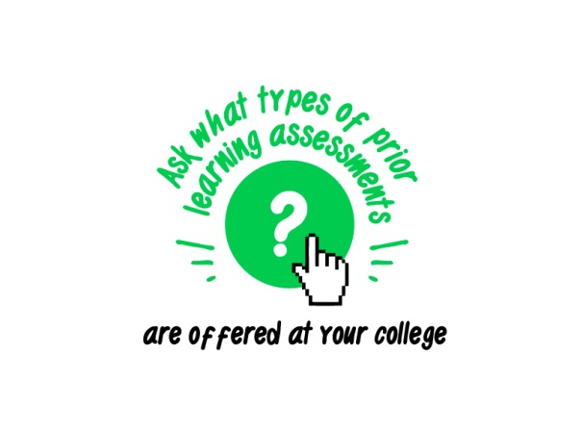
Scenario #2 - Student Orientation Event
Assumption: Students have enrolled, but may not be aware of PLA policies and opportunities. It’s important that they consider possible options for credit before course selection.
Audience: Currently enrolled students
Preparation:
- Be familiar with [college name]’s current PLA policy or check with someone from the Registrar or Dean’s office regarding the PLA policy details;
- Try to find examples of students that have pursued and completed the PLA process;
- Review Staff Guide to PLA (August 2015);
- Explore your college website to see what PLA information is shared;
- Invite someone from the Advising, Registrar, or Dean’s office to speak at the orientation event.
Discussion Guide:
- Ask the students if they had ever heard about PLA before this video. What are their thoughts about it?
- Ask the students what questions arose as they watched the video?
- Ask the students to take a moment to reflect on their own prior training, professional, and work experiences especially in the context of their current area of study and if they think that some of the lessons gained could translate into college credits (this could be a Pair-Share activity).
- You could also ask the students to think about or do a free-writing exercise about their prior learning experiences and then share with the group about how these learning experiences will help them in their current program of study even if they might not translate into college credit.
- Discuss what a PLA process might look like in your college and share a student’s PLA journey if you were able to locate one.
- Reiterate the Call to Action in the video by explaining the next steps that students might need to take to pursue a PLA process and share the contact information for the PLA point person.
What are some of your ideas for sharing this video with your students to increase their knowledge of and familiarity with PLA?
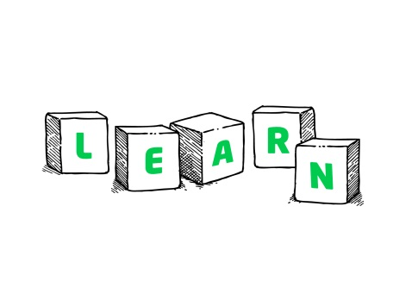
Scenario #3 – Engaging Faculty Academic Advisors
Purpose: To engage Faculty Advisors and enlist their support in the process of raising awareness of PLA among students.
Audience: Faculty Academic Advisors
Preparation:
- Be familiar with the Faculty PLA Guide (July 2015);
- Have a copy of [college name]’s current PLA policy ready to share;
- Share examples and details of challenge exams that are available for students in your program and college;
- Explore and share what PLA information is available on the college website.
Discussion Guide:
- Ask the Faculty Academic Advisor if they have had experience with PLA. What are their thoughts about it?
- Ask faculty how their students will respond to the video? How might it be useful in their academic advising process?
- Ask if they are familiar with any training and certification or military crosswalks in their department? Share, if you have found, crosswalk examples from other departments.
- Ask them if a particular course in their department is more likely to have incumbent workers or students with industry credentials.
- Ask how they can support campus/department efforts to raise awareness among students, for example, show the video to faculty, students in program, and assist students with self-assessment.

Download the PLA video at: http://www.collegetransition.org/PLAvideo.html

