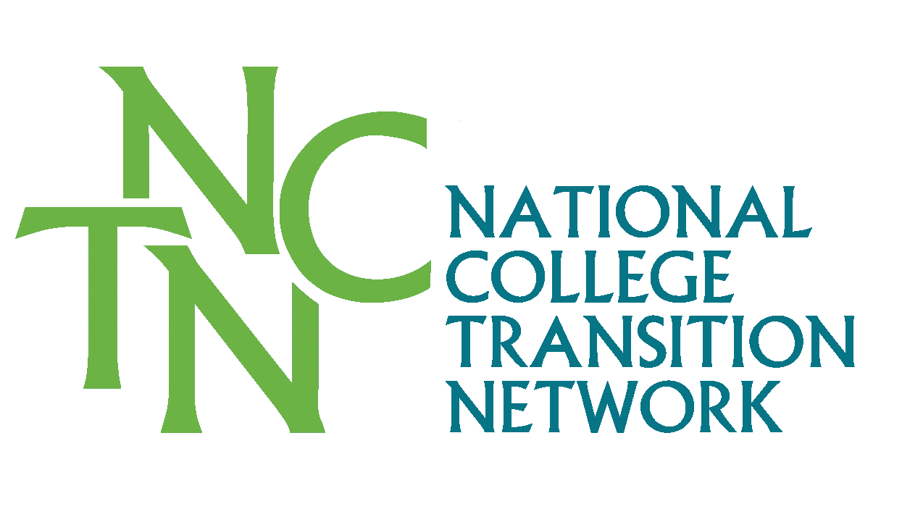
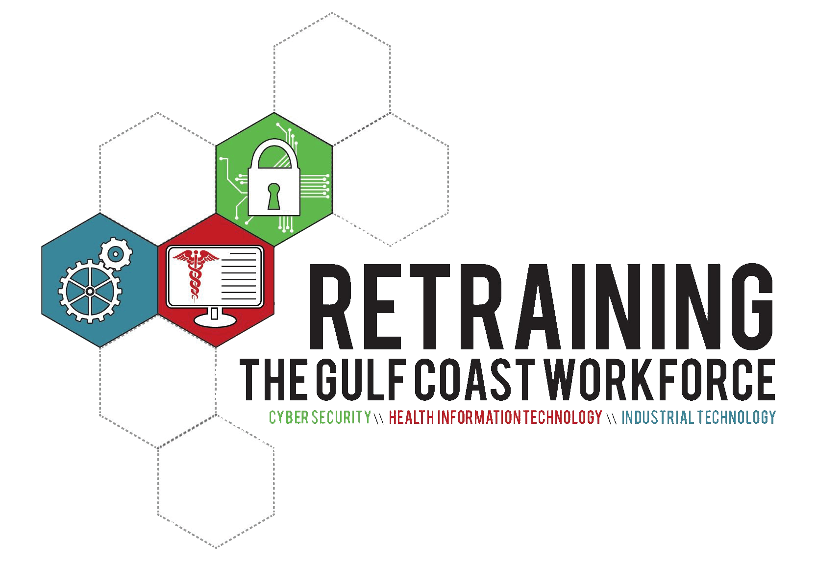

[Community College Name]
Credit FOR PRIOR LEARNING
EXAMINATION CROSSWALK

Credit for Prior Learning (CPL) is a process that enables learners to demonstrate what they have learned and translate that learning into college credit. College-level learning is validated through CPL when learners prove their mastery of the knowledge, skills, competencies, and abilities in a specific area of study offered by the college. Students can demonstrate such learning via standardized examinations offered by third-party vendors and validated by The College Board, or through professional or industry-based certifications.

ADVANCED PLACEMENT CREDIT CROSSWALK
The awarding of credit for advanced placement is based on two criteria:
1. Standard scores recommended by the Commission on Educational Credit for the American Council of Education, and
2. Minimum test score achievement as determined by the faculty.

CLEP Examination

EQUIVALENT [college name] COURSE | CLEP Exam | Criteria | Credit Hours Awarded
Course Name | CLEP Exam Name

DSST Examination

EQUIVALENT [college name] COURSE | DSST Exam | Criteria | Credit Hours Awarded
Course Name | DSST Exam Name

AP Examination

EQUIVALENT [college name] COURSE | AP Exam | Criteria | Credit Hours Awarded
Course Name | AP Exam Name

PROFESSIONAL CERTIFICATION CREDIT CROSSWALK
Courses eligible for Professional Certification Credit are determined by the faculty and validated by the Vice President of Academic Affairs.

EQUIVALENT [college name] COURSE | Professional Certification | Credit Hours Awarded
 | Certification Name

