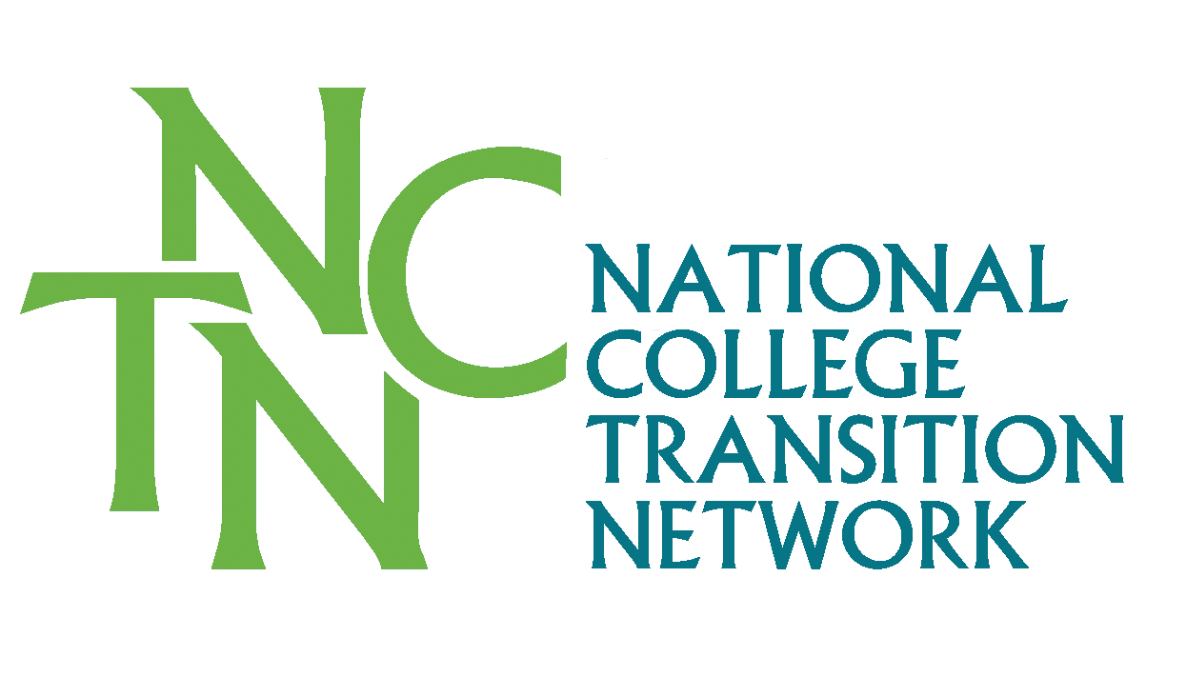
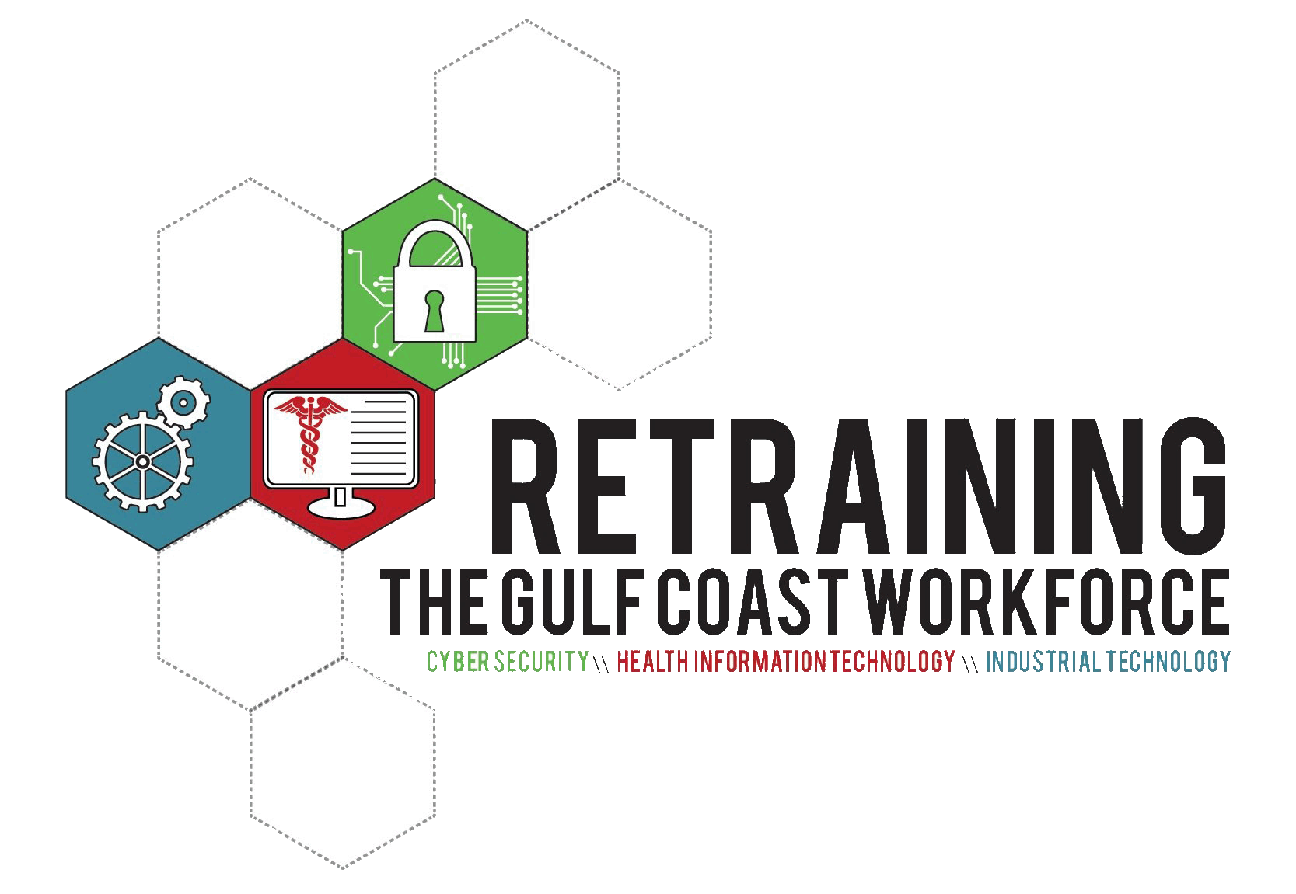
Faculty Guide to Prior Learning Assessment
And Challenge exams

What is PLA?
Prior Learning Assessment (PLA) is an acceleration and completion strategy to recognize and award credit for college-level learning. The process enables learners to demonstrate what they have learned and translate that learning into college credit. PLA validates knowledge acquired through life experience, work experience, military experience, civic engagement, individual study and reading, and participation in classes or training sponsored by business and industry, professional organizations or government agencies.

Credit is awarded for college-level knowledge gained from experience and not for the experience itself. College-level learning is validated through PLA when learners prove their mastery of the knowledge, skills, competencies, and abilities in a specific area of study offered by the college.

Why is PLA an Important Completion Strategy?
The U.S. is on collision course with regards to having a skilled workforce to meet the future needs of business and industry. By 2018, the U.S. economy will have jobs for 22 million with college degrees. Concomitantly, 63% of all jobs in the U.S. economy will require some type of postsecondary training. However, at the rate of production currently seen at colleges and universities there is a projected shortfall of nearly 8 million people with degrees. Accordingly:
- College completion rates are dismally low - only 34% of all college students graduate with a degree from a two or four-year college.
- Only 3 out of 10 students who start at a community college full-time graduates with an associate degree in three years.
- The United States ranks sixth in the world in postsecondary attainment among 25-64 year-olds with only 40.3% of the population holding an associate’s degree or higher.

We need an effective strategy to accelerate adult degree completion! Research on adults who have been awarded some type of credit for prior learning proves that PLA is an effective completion strategy. The Council for Adult and Experiential Learning (CAEL) studied more than 62,000 adult students from 48 postsecondary institutions and found that adults who earned credit through PLA had higher completion rates and lower time to degree than students who had not earned PLA credit. In fact, these learners were two-and-a-half times more likely to complete a degree! This was true for students regardless of race/ethnicity, age, financial aid status, or gender. Additionally, credit earned through PLA save students time and money in earning a degree.

PLA and Accreditation
Given the long history of advanced placement examinations, PLA has been recognized by accreditation organizations for a long time. What is the most clear and important in these standards is the important role played by the faculty in validating college-level learning. In MS and LA, all credits awarded for PLA, must be in accordance with Southern Association of Colleges and Schools Commission on Colleges (SACS) Standard 3.4.

The institution publishes policies that include criteria for evaluating, awarding, and accepting credit for transfer, experiential learning, credit by examination, Advanced Placement, and professional certificates that is consistent with its mission and ensures that course work and learning outcomes are at the collegiate level and comparable to the institution’s own degree programs. The institution assumes responsibility for the academic quality of any course work or credit recorded on the institution’s transcript.

Since PLA credit is awarded when faculty assess for college-level learning, where the student obtained the learning, say in a nontraditional setting or institution or through the college’s workforce education division, is not a criterion. If the college-level learning is evaluated and assessed by a college faculty member who meets SACS requirements, then PLA credit can be awarded based on such faculty evaluation.

Role of Faculty and Chief Academic Officer in PLA
Of utmost importance in awarding prior learning credit is the maintenance of academic integrity! Remember, college-level learning is validated through PLA when learners prove their mastery of the subject matter. Undoubtedly, faculty is responsible for the academic integrity of the curriculum. Therefore, the determination of credit awards or competency levels must be made by faculty or a subject matter expert whose experience and credentials are appropriate to a faculty position. Faculty should also be involved in the development of college policies and procedures for awarding PLA.

Most importantly, faculty must be involved in determining the types of assessments utilized for PLA and for the assessment criteria. Four standards are fundamental:
- Assessment must be directly related to the publicly identified course learning outcomes.
- All work assessed for PLA must meet a minimum of ”C” level proficiency for all of the course learning outcomes and/or technical competencies. This “C” level must be determined by the faculty to maintain academic integrity and rigor.
- Academic credit must only be awarded for those courses directly applicable to curriculum requirements in the student’s declared certificate or degree program as outlined in college publications (including website).
- PLA credits must not be treated differently in their application and use than their course equivalencies. PLA credits satisfy prerequisite requirements in the same manner that their course equivalencies do at the institution.

The college’s Chief Academic Officer (CAO) also plays a critical role in ensuring academic integrity. As the college administrator with responsibility for the faculty and the college curriculum the COA must:
- Confirm that PLA assessments are directly related to the course’s identified and publicized learning outcomes
- Ensure that the college policy and practices are followed.
- If a challenge exam is administered by someone at the college other than a faculty member, the CAO is responsible for ensuring the integrity of the process and that all policies are followed.

Ways to Award PLA Credit
Standardized Examinations
College Level Examination Program (CLEP)
CLEP assesses proficiency in general education through 33 tests in five subject areas including mathematics, writing, communications and science. Most CLEP examinations cover lower level and introductory knowledge in these subject areas. The awarding of CLEP credit should be based on two criteria: standard scores recommended by the Commission on Educational Credit for the American Council of Education, and minimum test score achievement as determined by the faculty. Cost is typically $80-90 per test. For more information, visit: http://clep.collegeboard.org

DSST
Formerly known as the DANTES program and now owned and administered by Prometric, DSST examinations test knowledge in both lower- and upper-level college material through 38 tests in six subject areas. Originally made available to military personnel, the DSST exams are now available to the general public for a fee of $80 per test. The awarding of DSST credit should be based on two criteria: standard scores recommended by the Commission on Educational Credit for the American Council of Education, and minimum test score achievement as determined by the faculty. For more information, visit: http://www.getcollegecredit.com

Advanced Placement (AP)
AP exams are a series of examinations developed by the College Board for AP High School classes in 19 subject areas. Faculty must be involved in determining the minimum test score achievement for awarding AP credits. For more information, contact: http://www.collegeboard.com/student/testing/ap/subjects

International Baccalaureate (IB)
The IB is an internationally accepted qualification for entry into institutions of higher education. Graduates of an IB program must demonstrate competency in languages, social studies, the experimental sciences and mathematics. For more information visit: http://www.ibo.org

For credit awarded at the Community College of the Air Force (CCAF), transfer credit should be awarded just like transfer credit awarded at any other accredited institution.

Challenge Examinations
Challenge examination development and assessment is the responsibility of the faculty! This ensures academic integrity and rigor. The assessment may include both a written examination and a practical examination of technical competency. No matter the type of assessment tool used, the challenge examination must be aligned with the approved and published course learning outcomes. Thus, faculty should develop challenge examinations in the same manner that they develop classroom assessment tools.

Course Learning Outcomes
Learning outcomes are statements that specify what learners will know or be able to do as a result of a learning activity. Outcomes are usually expressed as knowledge, skills, or abilities and are comprised of three types of learning: cognitive, affective and kinesthetic.

Course learning outcomes should be written in a manner that allows the faculty member to evaluate the student’s learning behavior. Learning outcomes are not about what the instructor provides but rather what the student can demonstrate. For example:
Students will be able to…..

To determine the criteria for success or desired performance, the learning outcome should use simple, specific action verbs to describe what students are expected to demonstrate.
Students will be able to ____ as exhibited by _____

When learning outcomes for a course are developed in this manner, faculty can develop:
- Tools and techniques to determine the extent to which the student learning outcomes are achieved.
- Direct measures of learning: exams, portfolios, and/or performance of a skill.
- A scoring rubric that identifies critical components of the work and discriminates differing levels of proficiency.

Assessment of these learning outcomes becomes the process of gathering and discussing information from multiple and diverse sources in order to develop a deep understanding of what students know, understand, and can do with their knowledge. Summative assessment techniques evaluate student learning as well as how they’ve mastered certain target skills. Consequently, challenge examinations should be developed utilizing the same assessments of learning as utilized in the classroom.

Challenge Examinations and Bloom’s Taxonomy
A helpful and frequently used resource when writing student learning outcomes is Bloom's Taxonomy of Cognitive Skills. Bloom’s Taxonomy measures learning through:
- Recognizing or recalling information
- Attaining knowledge of major ideas or subject matter
- Understanding, grasping meaning and interpretation
- Applying information to solve problems using requires skills or knowledge
- Analyzing a problem and utilizing knowledge to solve such problem
- Synthesizing, evaluating or arguing for the validity of a problem
- Creating, designing or generating a product

In developing a challenge examination for a course, faculty can utilize Bloom’s or a modified version to determine the components of the course. For example, after review of the curriculum, the faculty determine that the following types of learning should result from the course:

Knowledge or major ideas or subject matter 20%
Understanding, grasping meaning and interpretation 5%
Using information to solve problems 25%
Creating a product 50%

As is typical for most career-technical courses, part of the learning is cognitive or affective (in this case, 50%) and the other part of the course is kinesthetic. Thus, the faculty will development the challenge examination in two parts:
- 50% is cognitive – 100 point written examination
- 50% is kinesthetic – practical examination evaluated on a 100 point scale

Cognitive Assessment

Step 1: Determine the types of questions for the 100 point written examination based on learning outcomes and level of cognition

Learning Outcomes | Level of Cognition | Written Portion – Number of Test Questions | Percentage of Questions for 100 Point Exams
Knowledge of major ideas or mastery of subject matter | 20% | 40 | 40%
Understanding, grasping meaning, interpretation | 5% | 10 | 10%
Use information to solve problems using required skills or knowledge | 25% | 50 | 50%

Step 2: Rank learning outcomes via course frequency

Outcomes | Percentage of Quantity in Course | Number of Exam Questions
Learning Outcome A | 30% | 30
Learning Outcome B | 40% | 40
Learning Outcome C | 20% | 20
Learning Outcome D | 10% | 10

Step 3: Develop the assessment rubric based on frequency for each learning outcome
For example, Learning Outcome A accounts for 30% of the course, and therefore 30 questions.

Learning Outcome A | Percentage of Exam Questions as per Type of Cognition | Number of Written Questions
Knowledge of major ideas or mastery of subject matter | 40% | 0.4 * 30 = 12
Understanding, grasping meaning, interpretation | 10% | 0.1 * 30 = 3
Use information to solve problems using required skills or knowledge | 50% | 0.5 * 30 = 15

Step 4: Develop the Practical Examination using same standards as utilized in the course
For the practical examination, faculty should develop a rubric that identifies the critical components of the work and discriminates the differing levels of proficiency.

For example, students must machine a widget to the following tolerances:

Tolerance Grade
0.0 mm 100%
0.2 mm 90%
0.4 mm 80%
0.5 mm 75%
>0.5 mm Failure

Step 6: Combine the two scores to determine successful completion of the challenge examination
Written Examination Score 71%
Practical Examination Score 80%
Final Score (0.71 * 0.5) + (0.8 * 0.5) = 75.5%

Thus, the student successfully challenges the course and receives credit.

Professional Certification/Industry Credentials
Many colleges award equivalent course credit for professional certifications and state licensure. These industry-based certifications may have been earned in a corporate training program or through work experience. Many industry-based certifications have been evaluated by the American Council on Education and have been equated to courses required in select degree or certificate programs much like CLEP, DSST and others.

When colleges utilize professional certifications as an assessment tool or is an expected outcome in a credit course, the college should create a Certification Crosswalk. This crosswalk matches the industry-based certification to the college course. To challenge a course based on possessing a professional certificate, the student must provide the college with the appropriate documentation to validate the industry certification award. Colleges may place a time limit. For example, the industry certification must have been received within the past three years.
In some cases, faculty may not feel that a professional certification exam sufficiently proves mastery of course learning outcomes. For example, A+ is a paper examination. If in the course in which A+ is utilized learners are required to show mastery on a hands-on or practical examination, the college may require that students complete a practical challenge examination in tandem with the professional certification crosswalk.

Two colleges have created model industry-based certification crosswalks. At both colleges, faculty were involved in evaluating the certifications and comparing learning outcomes from the certifications with course identified learning outcomes.

Bossier Parish Community College (LA) – the college has created two crosswalks; one for industry-based certification and one for standardized challenge exams. Both are available on the college’s website and are an excellent tool for helping learners determine if they qualify for credit equivalency.

EQUIVALENT BPCC COURSE | CLEP Exam | Hours
ACCT 205 Elementary Accounting I | Financial Accounting | 3
EQUIVALENT BPCC COURSE | DSST (DANTES) Exam | Hours
BADM 105 General Business Administration | Introduction to Business | 3
EQUIVALENT BPCC COURSE | National Information Technology (IT) Certificates | Hours
CIT 114 Microsoft Windows | 72-680 TS: Windows 7, Configuring  OR  72-620 TS: Configuring Microsoft Windows Vista Client | 3

Ivy Tech Community College (IN) – was one of the first colleges in the country to complete a comprehensive crosswalk around every national certification.

Accounting Certifications | Ivy Tech Courses
American Institute of Banking (AIB) Course 1000 Accounting 1 AND AIB Course 1010 Accounting II | ACCT 101 Financial Accounting
American Institute of Professional Bookkeeping (AIPB) - Certified Bookkeeper | ACCT 101 Financial Accounting I  ACCT 106 Payroll Accounting
Manufacturing Certifications | Ivy Tech Course
Society of Manufacturing Engineers – Certified Manufacturing Technologies | ADMF 115 Materials and Processes for Manufacturing
MSSC Certified Logistics Associate CLA Assessment  and  MSSC Certified Logistics Technician CLT Assessment | ADMF 119 Logistics in Manufacturing

Portfolio Assessment
A PLA portfolio is a detailed documentation illustrating college-level learning. The documentation varies by course and may include: examples of documents developed or materials made (like a machined part) at work or during some civic engagement, a self-assessment, an essay or oral interview explaining knowledge and experience, awards and honors, and certifications showing completion of workshops or seminars offered by professional organizations, business and industry or government agencies. Preparation and content of the portfolio are the responsibility of the student and must be of sufficient in breadth and depth to validate the student’s stated learning and provide the evaluator(s) with qualitative evidence for evaluation. College advisors, designated faculty, staff member or subject matter experts may assist the student in the portfolio development processes and procedures.

Once the portfolio is submitted it is evaluated by designated faculty member, a subject matter expert or a college designated Portfolio Assessment Team to determine if the student has submitted sufficient documentation to demonstrate attainment and mastery of the specific course learning outcomes and/or technical competencies. Like challenge exams, best practices in portfolio assessment typically utilize a rubric or matrix that includes: identification of course learning outcomes, techniques for assessing each learning outcome, and a scoring technique for validating mastery.

July 13, 2015

Carnevale, A., Smith, N. and Strohl, J, “Help Wanted,” Center on Education and the Workforce, Georgetown University, (2010) https://cew.georgetown.edu/report/help-wanted/
National Center for Public Policy and Higher Education (2011, June). Affordability and transfer: Critical to increasing baccalaureate degree completion. Retrieved October 27, 2011, from http://www.highereducation.org/reports/pa_at/index.shtml
National Center for Higher Education Management Systems - Information Center for Higher Education Policymaking and Analysis (2009). Progress and completion: Graduation rates. Retrieved October 27, 2011, from http://www.higheredinfo.org/dbrowser/index.php?measure=19
College Board Advocacy and Policy Center (2011). The college completion agenda 2010 progress report executive summary. Retrieved October 27, 2011, from http://completionagenda.collegeboard.org/sites/default/files/reports_pdf/Progress_Executive_Summary.pdf
Klein-Collins, R. (2010). Fueling the race to postsecondary success: A 48-institution study of prior learning assessment and adult student outcomes. Chicago, IL: Council for Adult and Experiential Learning. Retrieved from http://www.cael.org/pdfs/PLA_Fueling-the-Race
Southern Association of Colleges and Schools – The Commission on Colleges. Policy 3.4.4 Principles of Accreditation.
Southern Association of Colleges and Schools – The Commission on Colleges. Policy 3.4.8 from “Comprehensive Standards.” Principles of Accreditation.
Southern Association of Colleges and Schools – The Commission on Colleges. Policy 3.4.10 from “Comprehensive Standards.” Principles of Accreditation.

