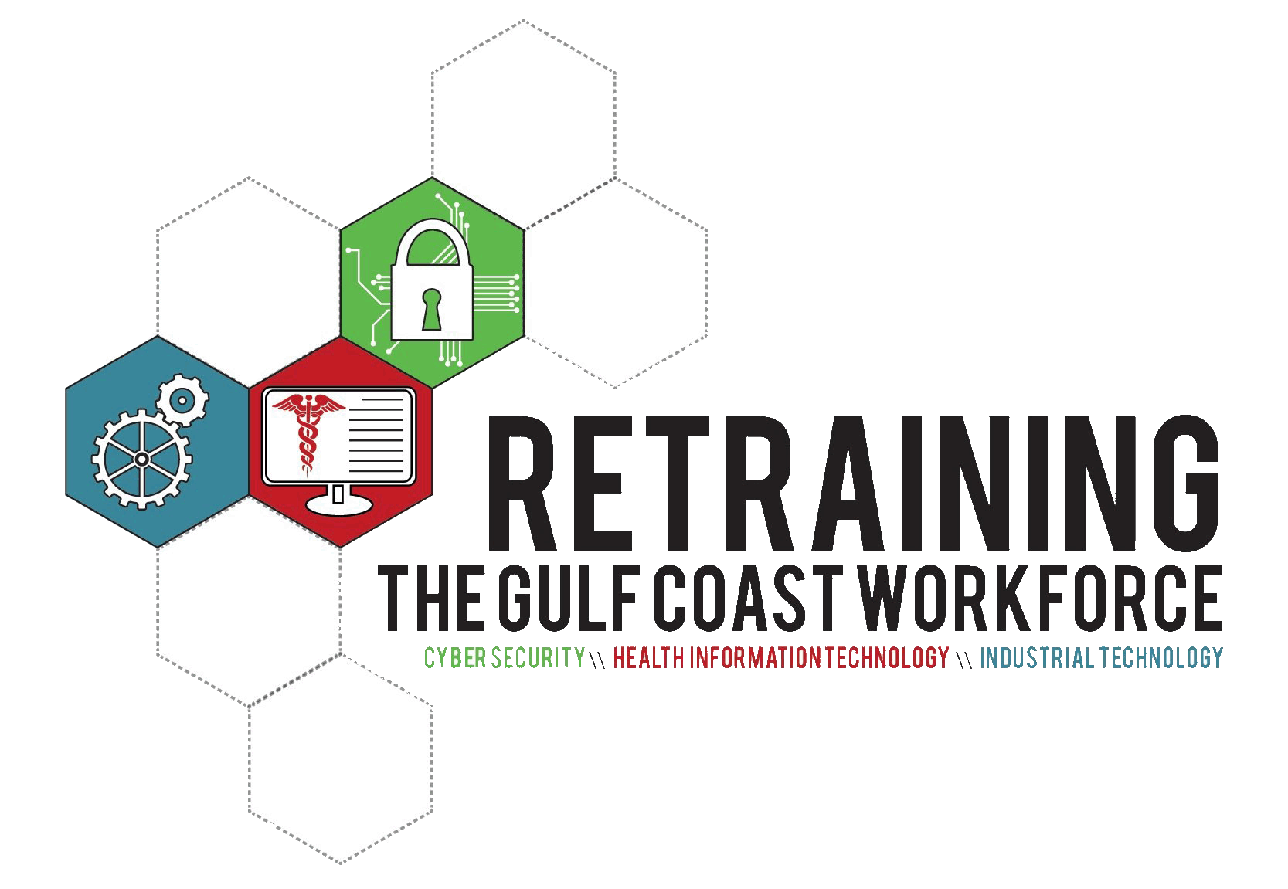
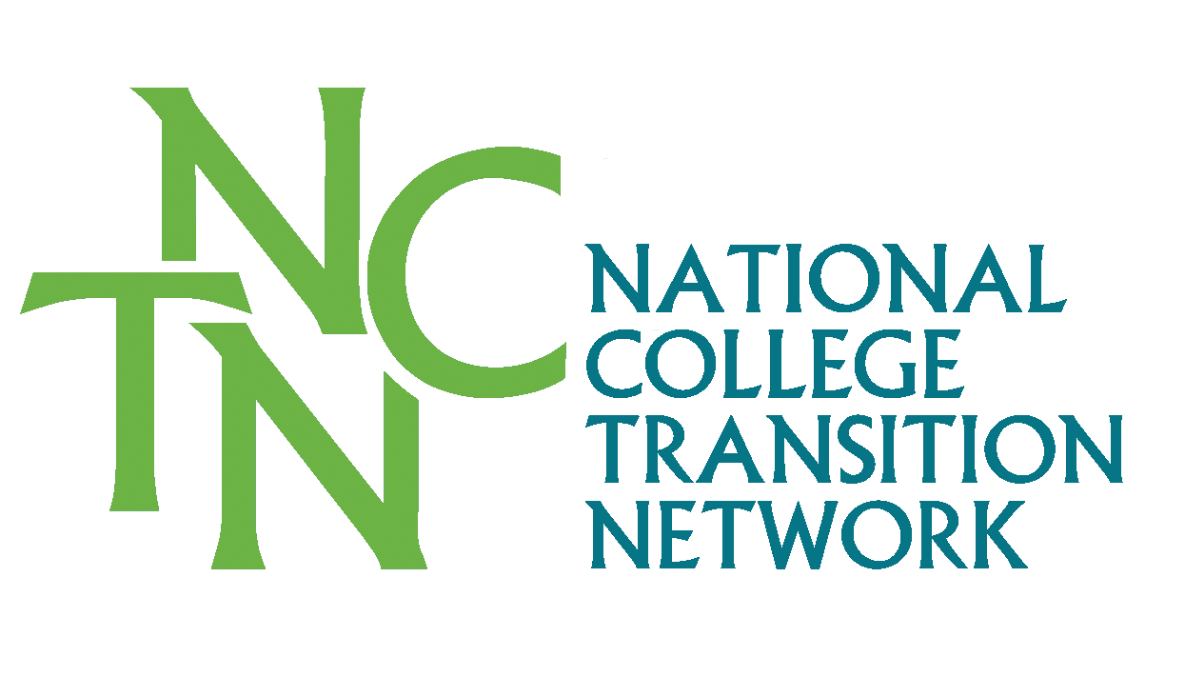
[Community College Name]

COMPANION GUIDE FOR STUDENT PLA VIDEO

Prior Learning Assessment (PLA) offers a proven pathway to increase student persistence and accelerate degree completion in higher education. A recent study conducted by the Council for Adult and Experiential Learning (CAEL), Fueling the Race to Postsecondary Success, affirms what to some may seem like conventional wisdom - when college students earn credit for content they already know, they show more positive academic results.
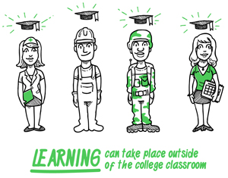
The Student PLA Video frames the value of lifelong learning experiences and the potential and value of receiving college credit for these informal learning opportunities. The PLA Video is geared towards students who are planning to apply for or have been accepted in a program of study in your community college. It can be shown at a student recruitment event, program orientation, or in a one-on-one advising setting.
The intention of this video is to raise students’ awareness about the potential of PLA and introduce them to the PLA processes in your community college. As Navigators, Advisors, and Program Coordinators, it is important for you to be familiar with the PLA policies and procedures in your college so that you can guide the students in their PLA next steps.

Video and Supporting Materials:
- Permanent Video Link: www.collegetransition.org/PLAvideo.html
- PLA Process and Policy documents specific to [college name].
- Military Credit Transcript Crosswalk specific to [college name].
- Credit for Prior Learning Examination Crosswalk specific to [college name].

The following are potential scenarios with assumptions, preparation suggestions, and discussion questions you can use when showing the video to specific target audiences.

Scenario #1 - Student Recruitment Event
Assumption: These are students are considering enrollment and are not aware of PLA policies or opportunities.
Audience: Prospective students
Preparation:
- Be familiar with [college name]’s current PLA policy or check with someone from the Registrar and/or Dean’s office regarding the PLA policy details;
- Try to find examples of students that have pursued and completed the PLA process;
- Review PLA Handbook for Staff;
- Explore your college website to see what PLA information is shared.
Discussion Guide:
- Ask the students if they had ever heard about PLA before this video. What are their thoughts about it?
- Ask the students what questions arose as they watched the video?
- Ask the students to take a moment to reflect on their own prior training, professional, and work experiences and make a note of some that they think that the learning gained could translate into college credits (this could be a Pair-Share activity).
- Discuss a sample PLA process in your college and share a student’s PLA journey story if you were able to locate one.
- Reiterate the Call to Action in the video by explaining the next steps that students might need to take to pursue a PLA process and share the contact information for the PLA point person.
What are some of your ideas for sharing this video with your students to increase their knowledge of and familiarity with PLA?

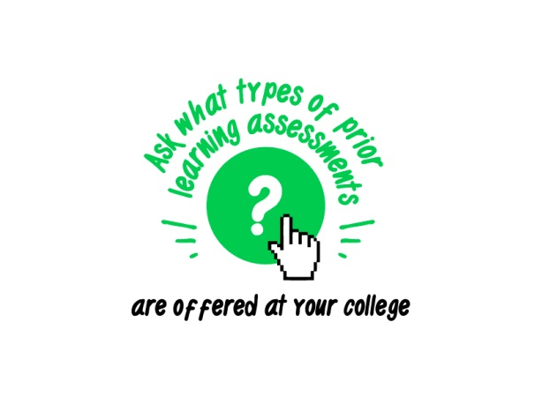
Scenario #2 - Student Orientation Event
Assumption: Students have enrolled, but may not be aware of PLA policies and opportunities. It’s important that they consider possible options for credit before course selection.
Audience: Currently enrolled students
Preparation:
- Be familiar with [college name]’s current PLA policy or check with someone from the Registrar or Dean’s office regarding the PLA policy details;
- Try to find examples of students that have pursued and completed the PLA process;
- Review PLA Handbook for Staff;
- Explore your college website to see what PLA information is shared;
- Invite someone from the Advising, Registrar, or Dean’s office to speak at the orientation event.
Discussion Guide:
- Ask the students if they had ever heard about PLA before this video. What are their thoughts about it?
- Ask the students what questions arose as they watched the video?
- Ask the students to take a moment to reflect on their own prior training, professional, and work experiences especially in the context of their current area of study and if they think that some of the lessons gained could translate into college credits (this could be a Pair-Share activity).
- You could also ask the students to think about or do a free-writing exercise about their prior learning experiences and then share with the group about how these learning experiences will help them in their current program of study even if they might not translate into college credit.
- Discuss what a PLA process might look like in your college and share a student’s PLA journey if you were able to locate one.
- Reiterate the Call to Action in the video by explaining the next steps that students might need to take to pursue a PLA process and share the contact information for the PLA point person.
What are some of your ideas for sharing this video with your students to increase their knowledge of and familiarity with PLA?

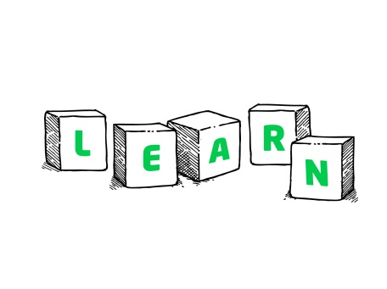
Scenario #3 – Engaging Faculty Academic Advisors
Purpose: To engage Faculty Advisors and enlist their support in the process of raising awareness of PLA among students.
Audience: Faculty Academic Advisors
Preparation:
- Be familiar with the Faculty PLA Guide;
- Have a copy of [college name]’s current PLA policy ready to share;
- Share examples and details of challenge exams that are available for students in your program and college;
- Explore and share what PLA information is available on the college website.
Discussion Guide:
- Ask the Faculty Academic Advisor if they have had experience with PLA. What are their thoughts about it?
- Ask faculty how their students will respond to the video? How might it be useful in their academic advising process?
- Ask if they are familiar with any training and certification or military crosswalks in their department? Share, if you have found, crosswalk examples from other departments.
- Ask them if a particular course in their department is more likely to have incumbent workers or students with industry credentials.
- Ask how they can support campus/department efforts to raise awareness among students, for example, show the video to faculty, students in program, and assist students with self-assessment.

Download the video at: http://www.collegetransition.org/PLAvideo.html

